Project Design Phase-II Data Flow Diagram & User Stories

|  |  |
| --- | --- |
| Date | 24.09.2022 |
| Team ID | PNT2022TMID41917 |
| Project Name | Smart Solutions for Railways |
| Maximum Marks | 4 Marks |

# Data Flow Diagrams:

A Data Flow Diagram (DFD) is a traditional visual representation of the information flows within a system. A neat and clear DFD can depict the right amount of the system requirement graphically. It shows how data enters and leaves the system, what changes the information, and where data is stored.

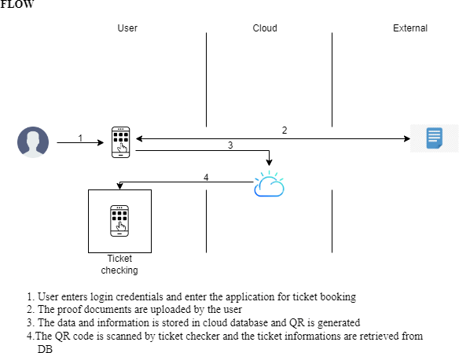

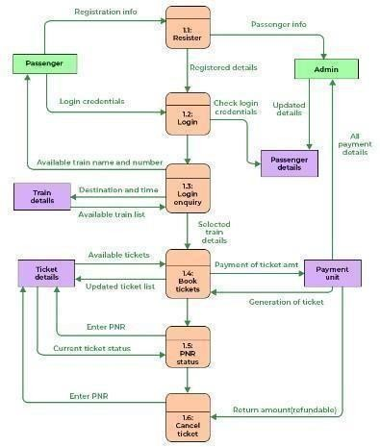

# User Stories

Use the below template to list all the user stories for the product.

|  |  |  |  |  |  |  |
| --- | --- | --- | --- | --- | --- | --- |
| **User Type** | **Functional Requirement (Epic)** | **User Story Number** | **User Story / Task** | **Acceptance criteria** | **Priority** | **Release** |
| Customer (Mobile user) | UI | USN-1 | As a user, I can register for the application by entering my email, password, and confirming my password. | I can access my account / dashboard | High | Sprint-1 |
| Customer (Mobile user) | Login Page | USN-2 | As a user, I will receive confirmation email once I have registered for the application | I can receive confirmation email & click confirm | High | Sprint-1 |
| Customer (Mobile user) | Reserving ticket | USN-3 | As a user, I can register for the application and enter the details for reserving the ticket. | I can view, modify the details | High | Sprint-2 |
| Customer (Webuser) | Reserving ticket | User | Enter the details and click submit button tobook ticket | I can book tickets and get QR code | High | Sprint-2 |
| Customer (Mobile user) | Dashboard | Users | The details can be stored and retrieved | I can change the information when required | Medium | Sprint-3 |
| Customer Care Executive | Connecting the service provider | Customer | Connects with the service by logging in | Can get connected with the server | Medium | Sprint-3 |
| Administrator | Provides the services | Admin | The data is given by the user | Can add or update the data provided by the user | High | Sprint-1 |